Document History
Version Number | Record Date | Prepared/  Modified By | Reviewed By | Change Details
0.1 | 31/03/2014 | Tanawat, Nattakit | PF,NC | - Draft
0.3 | 11/05/2014 | Tanawat,  Nattakit | PF,NC | - Draft
0.4 | 28/05/2014 | Tanawat, Nattakit | PF,NC | - Draft
0.6 | 09/06/2014 | Tanawat, Nattakit | PF,NC | - Draft
0.7 | 18/06/2014 | Tanawat, Nattakit | PF,NC | - Draft
0.8 | 14/07/2014 | Tanawat, Nattakit | PF,NC | - Draft
0.9 | 28/07/2014 | Tanawat, Nattakit | PF,NC | - Draft

Document Designed by
Tanawat Sitthitan
Nattakit Chaiwongsri
July 31, 2014
Document Approved by
_______________
Mr. Phudinan Singkhamfu
August 27, 2014

Content
Chapter 1 | Introduction 2
1.1 Purpose 2
1.2 Project Scope 2
1.3 Definition, Acronyms, and Abbreviation 2
1.3.1 Key definition 2
1.3.2 Keys Acronyms and Abbreviations 3
1.4 User Characteristic 3
Chapter 2 | System Architecture 4
Chapter 3 | Detailed Design 6
3.1 Class diagram 6
3.1.1 Promotion provider class diagram 6
3.1.2 Promotion provider class diagram description 7
3.2 ER-Diagram 21
3.3 Sequence Diagram 22
3.3.1 Admin login 22
3.3.2 Admin add member account 23
3.3.3 Admin edit member account 24
3.3.4 Show list of member 25
3.3.5 Admin can delete member 26
3.3.6 Admin can add promotion 27
3.3.7 Admin can edit promotion 28
3.3.8 Admin can delete promotion 29
3.3.9 Admin can accept register request 30
3.3.10Admin can reject register request 31
3.3.11 Members can add promotion 32
3.3.12 Member can edit promotion 33
3.3.13 Members can delete promotion 34
3.3.14 Members can edit their profile 35
3.3.15 Members can change password for account security 36
Chapter 4 | User Interface Design 37
1. Index page 37
2. Promotion list 38
3. Account list 39
4. Request list 40
5. Add promotion 41
6. Edit promotion 42
7. Add account 43
8. Edit acocount 44

Chapter 1 | Introduction

1.1 Purpose
The Software Design Document (SDD) is document to provide documentation, which will be used to aid in software development by provide the detail of how the software should be built. In the Software Design Document are narrative and graphical documentation of the software design for this project.
This document contains design description of the promotion provider. This includes the architectural feature of the system down though detail of what operations will perform. It also shows how the use cases promised in the SRS would be implementation in the system using this design.

1.2 Project Scope
This Software Design Document provides description of the design of the promotion provider. The dominant design methodology is an object-oriented design combines with Model-View-Controller
This Software Design Document is for a high level system, which will work as a proof of the concepts. This software design is focused on the high-level system and critical parts of the system.

1.3 Definition, Acronyms, and Abbreviation

1.3.1 Key definition

Design | “The period of time in the software lift cycle during which the design for architect, software components, interfaces, and data are created, and verified to satisfy requirement.”[IEEE90]
Entity Relationship  Diagram | “data modeling technique that creates a graphical representation of the entities, and the relationships between entities, within an information system.”  [techtarget.com]
iOS | “the operating system in the iPhone and iPod touch. ”
System Architecture | “a generic discipline to handle objects (existing or to be created) called "systems", in a way that supports reasoning about the structural properties of these objects.”  [Lix.polytechnique.fr]
Client | “a client is an application that runs on a personal computer or workstation and relies on a server to perform some operations. For example, an e-mail client is an application that enables you to send and receive e-mail.”

1.3.2 Keys Acronyms and Abbreviations
Key Acronyms | Abbreviation
SRS | System Requirement Specification
SDD | Software Design Document
ERD | Entity Relationship Diagram
GUI | Graphic User Interface
SD | Sequence Diagram

1.4 User Characteristic
Administrator should be able to:
- Login to web application
- Logout from web application
- Add member account
- Member account
- Delete member account
- Add promotion
- Edit promotion
- Delete promotion
- Accept register request
- Register request

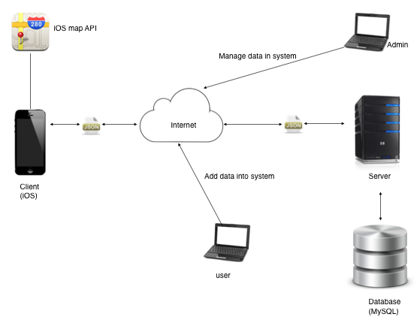
Chapter 2 | System Architecture
Figure 1: System Architecture
This project will have 2side, the first is client side that is the iPhone application. The client will use apple API to provide a map. The second is server side that are web and database. In this system client need to connect a server, then server will connect to the database and sent the data back to the client via the internet in the form of JSON. The application(client) cannot work without connect to server because every data and information of the restaurant of the hotel will store in the database server. User(Hotel or restaurant) can add promotions into our system, and admin can also manage data in the system which are adding, editing and deleting.

Chapter 3 | Detailed Design

3.1 Class diagram

3.1.1 Promotion provider class diagram
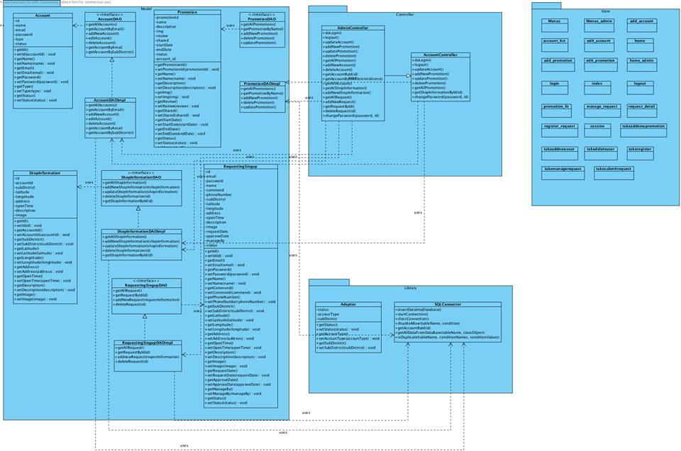

3.1.2 Promotion provider class diagram description

Class name: Account Controller

Method name | Description | Remark
doLogin | This method will verify the login information | Return true or false
logout | This method will verify the log out from web service.
updateAccount | This method will updates an existing account’s information
addNewPromotion | This method will add new promotion to database
updatePromotion | This method will updates an existing promotion’s information
deletePromotion | This method will delete a promotion from database
getAllPromotion | This method will query all promotion data from the database | Return promotion list
getShopinformationById | This method will query shop data from the database by id of shop | Return shop information

Class name: Admin Controller

Method name | Description | Remark
doLogin | This method verifies the login information | Return true or false
logout | This method verifies the log out from web service.
updateAccount | This method updates an existing account’s information
addNewPromotion | This method will add new promotion to database
updatePromotion | This method will updates an existing promotion’s information
deletePromotion | This method will delete a promotion from database
getAllPromotion | This method will query all promotion data from the database | Return promotion list
addNewAccount | This method will add new account to database
deleteAccount | This method will delete a account from database
getAccountByid | This method will query account data from the database by id of account | Return accountDAOImpl
getAccountBysubdistrict | This method will query account data from the database by sub district of account | Return accountDAOImpl
getAllAccount | This method will query all account data from the database | Return accountDAOImpl
getAllShopInformation | This method will query all shop data from the database | Return shopInformation
addNewShopInformation | This method will add new shop data to database
getAllRequest | This method will query all request data from the database | Return reqestingSignupDAOImpl
addNewRequest | This method will add new request data to database
getRequestByID | This method will query request data from the database by id of request | Return requsSignup
deleteRequest | This method will delete a request from database

Class name: Adaptor

Method name | Description | Remark
getStatus | This method will query status | Return Status
setStatus | This method will insert status
getAccountType | This method will query account type | Return Account Type
setAccountType | This method will insert account type
getSubDistrict | This method will query sub district | Return Sub district
setSubDistrict | This method will insert sub district

Class name: SQL Connector

Method name | Description | Remark
InsertDataIntoDatabase | This method verifies the login information
startConnection | This method verifies the log out from web service.
closeConnection | This method updates an existing account’s information
disableARow | This method updates an existing account’s information
getAccountById | This method will query account data from the database by id of account
getAllDataFromDataBase | This method will query data from database
isDuplicate | This method will check the repeated data | Return true or false

Class name: Account

Method name | Description | Remark
GetId | This method will query Id | Return Id
setId(accountId) | This method will insert account Id
GetName | This method will query name | Return Name
setName(Name) | This method will insert name
GetEmail | This method will query email | Return email
SetEmail | This method will insert email
GetPassword | This method will query password | Return password
setPassword(password) | This method will insert password
getType | This method will query type | Return type
setType(type) | This method will insert type
getStatus | This method will query status | Return status
setStatus(Status) | This method will insert status

Class name: AccountDAOImpl

Method name | Description | Remark
getAllAccount | This method verifies the login information | Return SQLConnector
getAccountByEmail | This method will query account data from the database by email of account | Return account or null
addNewAccount | This method will add new account to database
editAccount | This method updates an existing account’s information
deleteAccount | This method disable an existing account
getAccountByArea | This method will query account data from the database by area of account | Return account or null
getAccountBySubDistrict | This method will query account data from the database by sub district of account | Return account or null

Class name: Promotion

Method name | Description | Remark
GetPromotionId | This method will query promotion Id | Return promotionId
setPromotionId(promotionId) | This method will insert promotion Id
GetName | This method will query name | Return name
setName(Name) | This method will insert name
GetDescription | This method will query Description | Return description
SetDescription(description) | This method will insert name
GetImg | This method will query Img | Return Img
setImg(Img) | This method will insert Img
getReview | This method will query Review | Return review
setReview(review) | This method will insert name
getShared | This method will query Shared | Return shared
setShared(Shared) | This method will insert name
getStartDate | This method will query start date | Return start date
setStartDate | This method will insert start date
getEndDate | This method will query end date | Return end date
setEndDate | This method will insert end date
getStatus | This method will query status | Return status

Class name: PromotionDAOImpl

Method name | Description | Remark
getAllPromotions | This method will query all promotion data from the database | Return SQLConnector
getPromotionByName | This method will query promotion data from the database by name of promotion
addNewPromotion | This method will add new promotion to database
deletePromotion | This method will delete a promotion from database
updatePromotion | This method will updates an existing promotion’s information

Class name: ShopInformation

Method name | Description | Remark
getId | This method will query Id | Return Id
setId(Id) | This method will insert Id
getAccountId | This method will query accountId | Return accountId
setAccountId(AccountId) | This method will insert accountId
getSubDistrict | This method will query sub district | Return subDistrict
setSubDistrict(subDistrict) | This method will insert sub district
getLatitude | This method will query latitude | Return latitude
setILatitude(latitude) | This method will insert latitude
getLongtitude | This method will query longitude | Return longitude
setLongtitude(longtitude) | This method will insert longitude
getAddress | This method will query address | Return address
setAddress(Address) | This method will insert address
getOpentime | This method will query open time | Return open time
setOpentime | This method will insert open time
getDescription | This method will query description | Return description
setDescription | This method will insert description
getImage | This method will query Image | Return image

Class name: ShopInformationImpl

Method name | Description | Remark
getAllShopInformation | This method will query all shop data from the database | Return SQLConnector
addNewShopInformation | This method will add new shop to database
deleteShopInformation | This method will delete a shop from database
updateShopInformation | This method will updates an existing shop’s information
getShopInformationById | This method will query shop data from the database by id of shop | Return shop information or null

Class name: RequestSignup

Method name | Description | Remark
getId | This method will query Id | Return Id
setId(Id) | This method will insert Id
getEmail | This method will query accountId | Return email
setEmail(email) | This method will insert accountId
getPassword | This method will query sub district | Return password
setPassword(password) | This method will insert sub district
getName | This method will query name | Return name
setName(name) | This method will insert name
getPhoneNumber | This method will query phone number | Return phoneNumber
setPhoneNumber | This method will insert phone number
getSubDistrict | This method will query sub district | Return subDistrict
setSubDistrict | This method will insert sub district
getLatitude | This method will query latitude | Return latitude
setLatitude | This method will insert latitude
getLongitude | This method will query longitude | Return longitude
setLongitude | This method will insert longitude
getAddress | This method will query address | Return Address
setAddress | This method will insert address
getOpentime | This method will query open time | Return open time
setOpentime | This method will insert open time
getDescription | This method will query description | Return description
setDescription | This method will insert description
getImage | This method will query Image | Return image
setImage | This method will insert Image
getRequestDate | This method will query request data | Return requestDate
setRequestDate | This method will insert request data
getApproveDate | This method will query approve data | Return approveDate
setApproveDate | This method will insert approve data
getManageBy | This method will manage by | Return manageBy

Class name: RequestingSignupDAOImpl

Method name | Description | Remark
getAllRequest | This method will query all request data from the database | Return SQLConnector
getRequestById | This method will query request data from the database by id of request | Return request or null
addNewRequest | This method will add new request to database
deleteRequest | This method will delete a request from database

3.2 ER-Diagram

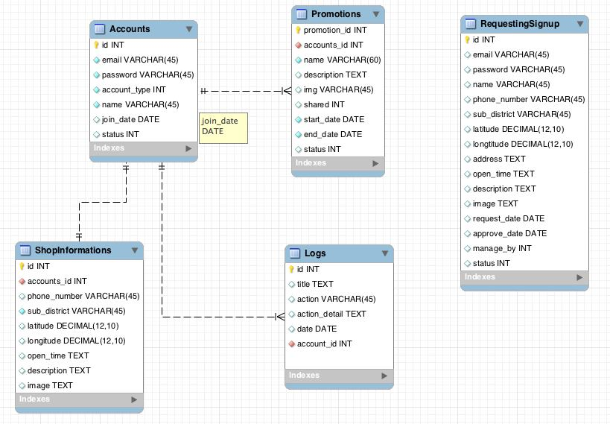

3.3 Sequence Diagram

3.3.1 URS-01: Admin can login to web application

SD-01 Admin login to web service sequence diagram

3.3.2 URS-02: Admin can logout from web application
SD-02 Admin add member account database sequence diagram

3.3.3 URS-03: Admin can add member account

SD-03 Admin edit member account in web service sequence diagram

3.3.4 URS-04: Admin can edit member’s profile

SD-04 Admin see list of member in web service sequence diagram

3.3.5 URS-05: Admin can delete member account

SD-05 Admin delete member in web service sequence diagram

3.3.6 URS-06: Admin can add promotion

SD-06 Admin add new promotion sequence diagram

3.3.7 URS-07: Admin can edit promotion

SD-07 Admin update promotion information sequence diagram

3.3.8 URS-08: Admin can delete promotion
SD-08 Admin delete promotion from database sequence diagram

3.3.9 URS-09: Admin can accept register request

SD-09 Admin response to accept register request sequence diagram

3.3.10 URS-10: Admin can reject register request

SD-10 Admin response to reject register request sequence diagram

3.3.11 URS-11: Members can add promotion

SD-11 Members add new promotion sequence diagram

3.3.12 URS-12: Members can edit promotion

SD-12 Members update promotion information sequence diagram

3.3.13 URS-13: Members can delete promotion

SD-13 Members delete promotion sequence diagram

3.3.14 URS-14: Members can edit their profile

SD-14 Members update their own profile sequence diagram

3.3.15 URS-15: Members can change password for account security

SD-15 Members change password sequence diagram

Chapter 4 | User Interface Design

1. Index page
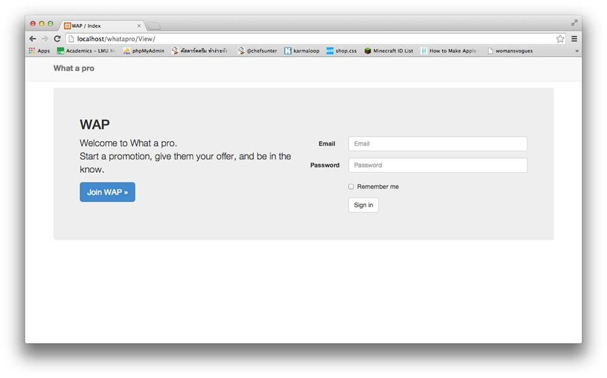This layout presented the main page of web service.

2. Promotion list
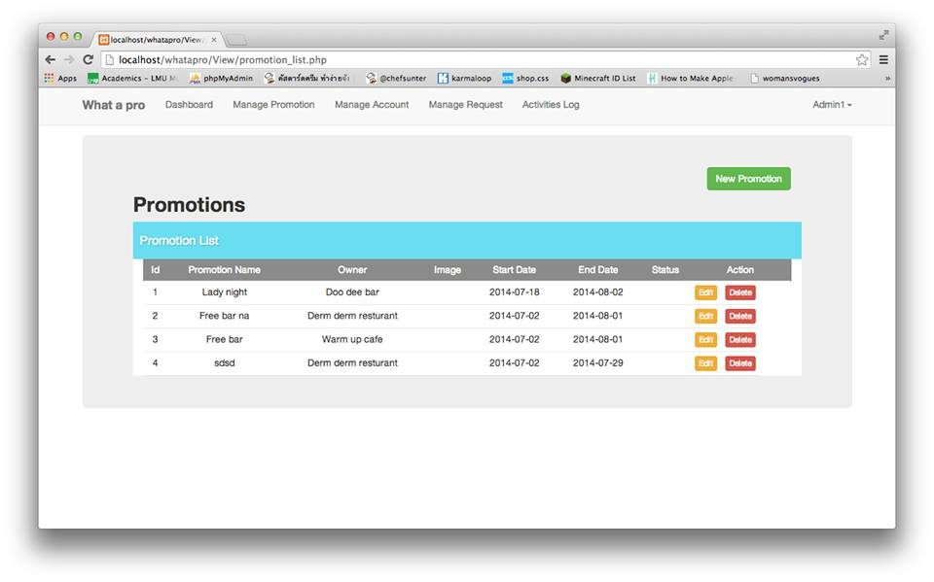
This layout presented the promotion page, allowing to add, edit, delete promotion.

3. Account list

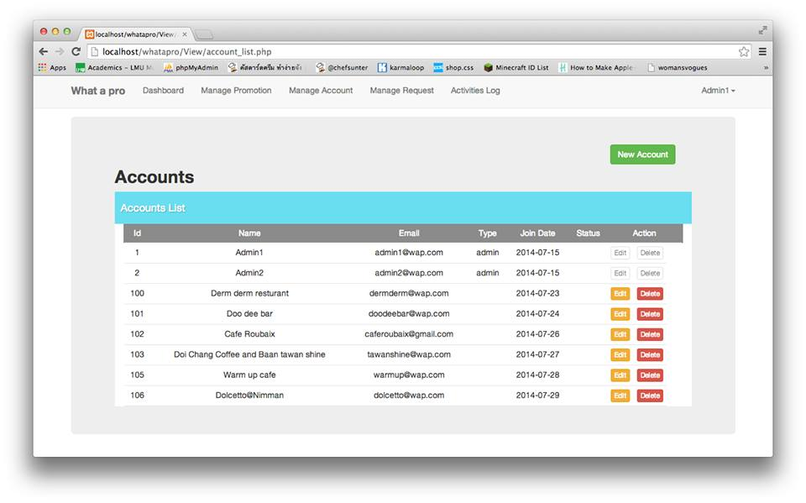
This layout presented the promotion page, allowing to add, edit, delete account.

4. Request list
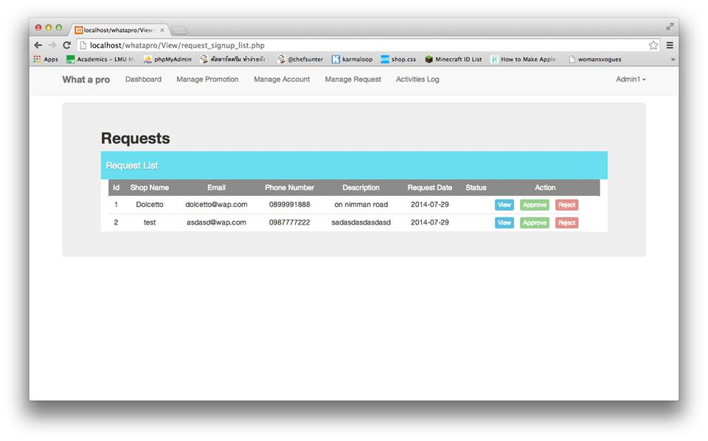
This layout is for admin to see request list and choose to accept or reject from this page.

5. Add promotion

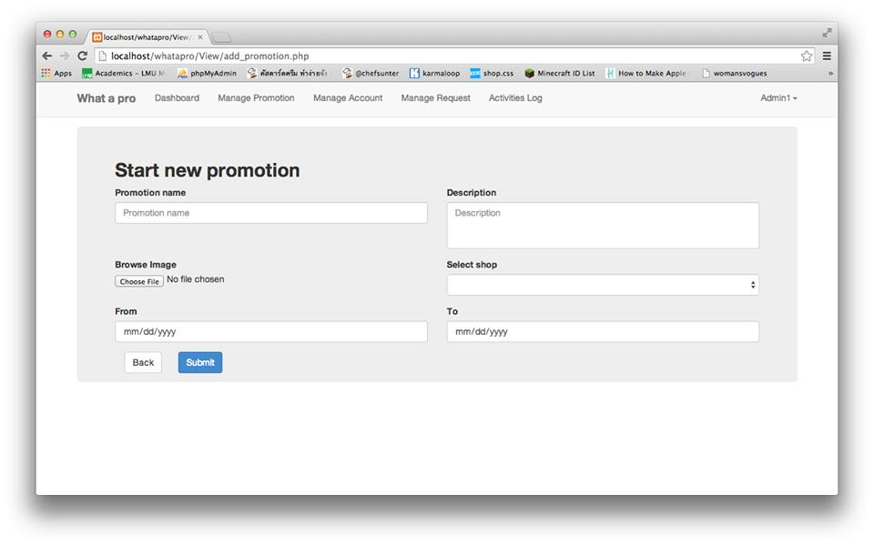
This layout is presenting an application from to add promotion.

6. Edit promotion

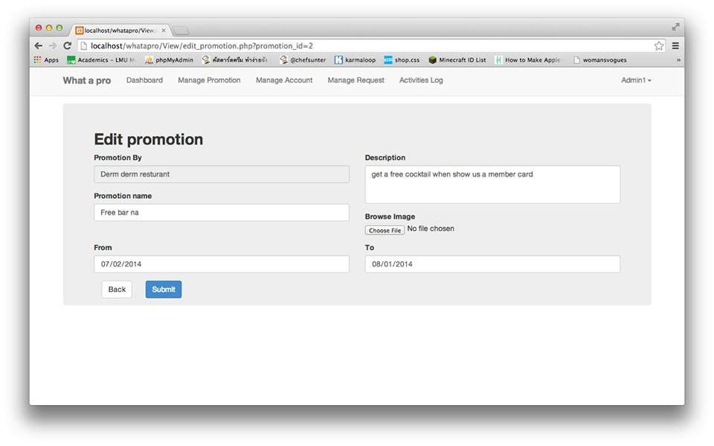
This layout is presenting an application from to add promotion.

7. Add account

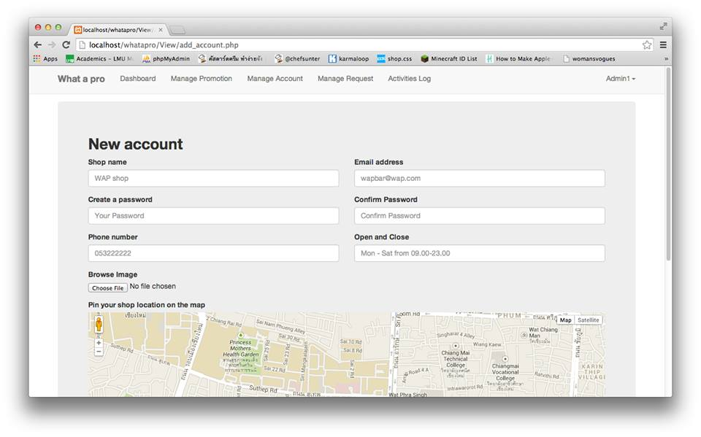
This layout is presenting an application from to add account.

8. Edit acocount
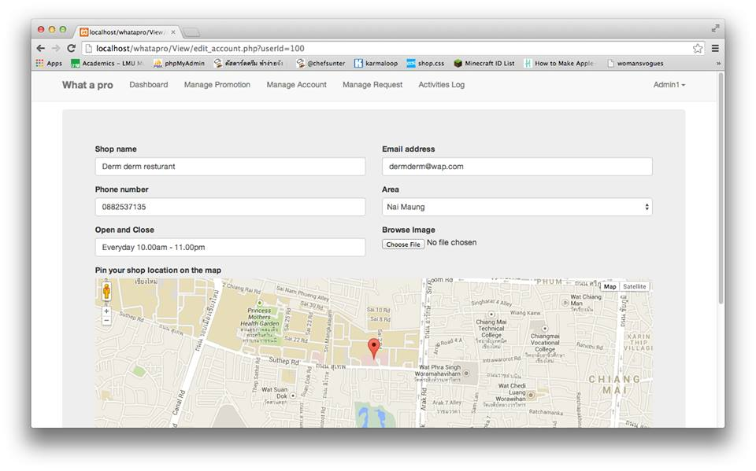
This layout is presenting an application from to edit account.

